**Connecting to Google BigQuery**

[Google BigQuery](https://cloud.google.com/bigquery/what-is-bigquery) is a web service for querying massive datasets that take advantage of Google's cloud infrastructure.

**Step - 1: Developers Console Project**

You need to create or use an existing project in the Google Developers Console as a first step. A project acts as a container in the Google Cloud Platform which stores information about billing and authorized users and contains BigQuery data.

Go to <https://console.developers.google.com/cloud-resource-manager> and sign in to your Google account.

You will see a list of existing projects, or you can click **Create project**.

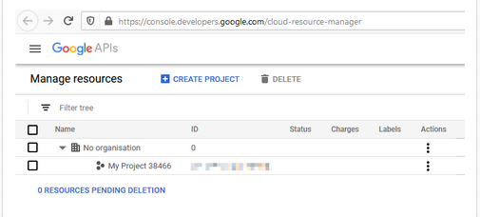

**Step - 2: Enable the BigQuery API**

To check that the BigQuery API is enabled, click the menu button in the top-left corner, and go to the [API & Services dashboard](https://console.developers.google.com/apis/dashboard).

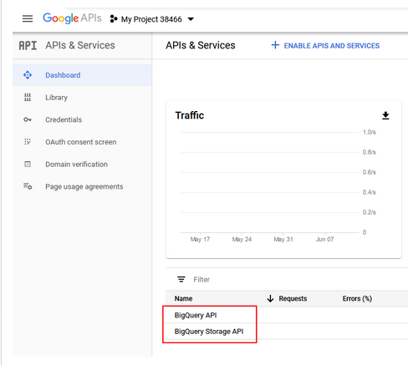

Ensure your project is selected as the current project in the top-left corner. You can enable the BigQuery API on this page if not already listed.

**Step - 3: Service Account Credentials**

To create or manage service accounts, in the API Manager, click **Credentials** in the left navigation. On the right, click **Create credentials** and select the **Service account** option.

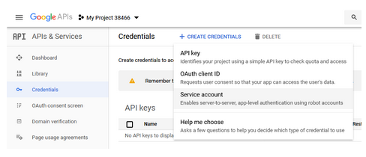

Enter a name and role for your service account.

When done, add a key for your service account. For example, click to edit the service account, then click **Add Key**. Choose a **JSON** key type.

When finished, a certificate file should be downloaded.

Note:

Add the json file and these two files under the “/content/ml-praticals-ldrp/e_commerce/e_commerce/” path:

<https://drive.google.com/file/d/1upNPpku8AX-0s-wDpqX3hilDFRcexzTe/view?usp=sharing>

<https://drive.google.com/file/d/1cteSr2iodxTu5kanndWnK84ZSuym-won/view?usp=sharing>